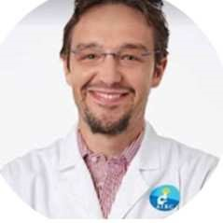PROF. FABIO PAGNI
Università Milano Bicocca
Dipartimento di Medicina e Chirurgia
Via Cadore 48, 20900 Monza Italia
Building U8,
(+39) 338 1833651 fabio.pagni@unimib.it
POSIZIONI ACCADEMICHE
09/2019 – 01/2025 | Professor of Pathology (MED08- 06/A4)  Università Milano Bicocca  - 2019-2025: Director Residency Program of Pathology UNIMIB  - 2023-2925 Director of the Departmental Center of Digital Medicine UNIMIB  - Member of the Educational Committee of the European Society of Pathology  - Responsible PMMP, Italian Society of Pathology SIAPEC
11/2010 - 08/2019 | Researcher
University Milan Bicocca - Milan

EDUCATION AND TRAINING
2021 Master in Health Management DIAS (Corso di Formazione Manageriale
per Direzione di Azienda Socio-Sanitaria, DIAS)
POLIS-Regione Lombardia - Milan

2010 School of specialization in Pathology
University Milan Bicocca - Milan

2009 Fellowship at Centro Diagnostico Italiano, Oncological Consultation
Center, Chief Juan Rosai - Milan

2005 MD: Pathology
University Milan Bicocca - Milan

PROFESSIONAL PROFILE

CLINICAL ASSISTANCE
The main clinical fields of interest are:
- HISTOPATHOLOGY: thyroid pathology, nephropathology and hematopathology;
- CYTOPATHOLOGY: lung and thyroid pathology;
- MOLECULAR PATHOLOGY: coordination of the Oncological Molecular Pathology Unit and the NGS facility at IRCCS San Gerardo Hospital, Monza
He is an experienced pathologist, being responsible for the US-guided clinic for thyroid FNA at IRCCS San Gerardo Hospital, Monza (around 1000 personally performed thyroid biopsies/year).

RESEARCH
The main field of interest is molecular pathology, as the application of omics for the diagnosis of both neoplastic (thyroid) and inflammatory (kidney) conditions. Fabio Pagni has spent the last years improving his knowledge in proteomics and NGS to detect new diagnostic approaches in pathology. The potential correlation of the proteomics profiles with the genomic data could help in discriminating new targets, transferable in the routine practice.
Recently he coordinated the transition of his lab from a traditional workflow to digital pathology. Both light microscopy and fluorescence scanners were introduced in the routine practice and changed the diagnostic process, offering a great resource for the research field, where the computational pathology era began.

EDUCATION
He directs the School of Specialization in Pathology at UNIMIB
(www.apunimib.it)
He coordinates different courses at UNIMIB both in the Medicine and Surgery Faculty and Technical Lab/ Odontoiatry Schools.

PROFESSIONAL SKILLS

GRANTS
Principal Investigator of the following competitive grants:

- AIRC My First Airc Grant 2016 (PI, 220,000 euro; proteomic classifier for indeterminate thyroid lesions);
- Minister of Health Ricerca Finalizzata 2019 (PI, 450,000 euro; GR2019-1236859 proteomics for the classification of follicular thyroid neoplasms: a project to save thyroid);
- Regione Lombardia DGR 3776/2020 (Co-PI, 1,700,000 euro; NephropaTHy-SpatialOMx integrated platform for the diagnosis of thyroid diseases);
- PNRR Next Generation EU (Coordinator Unit 3 - 1,000,000 euro; PNRR-MR1-2022-12375735 Diplomat, DIgital PLatform for OMics and Artificial intelligence in Transplant and native rare renal diseases).
- DGR n. XI/6989/2022 Regione Lombardia NGS Facility (Principal Investigator for IRCCS San Gerardo, Monza, 200,000 euro)
- He is the Principal Investigator for the Department of Medicine and Surgery, UNIMIB of the MUR- Dipartimento di Eccellenza 2023-2027 (Impact Medicine IMaging e PAtologia digitale CombinaTi per nuove traiettorie di diagnosi e terapia, 9,000,000 euro).
- ANTHEM, Principal Investigator spoke 1.5 (70,000 euro)

TRACK RECORD SUMMARY (2018-2023)
https://pubmed.ncbi.nlm.nih.gov/?term=pagni+f&sort=date

Author of more than 200 PUMED indexed papers since 2007
H-index (Scopus): 29

LANGUAGES
Italian

English : European certification (2004):
level B1 (Spoken interaction)- level B2 ( Grammatical knowledge)
British School of Monza

HOBBIES
• Tennis player since the childhood (max. Italian Chart: 3.4) • Father of 3 boys: Pietro, Leonardo and Santiago.
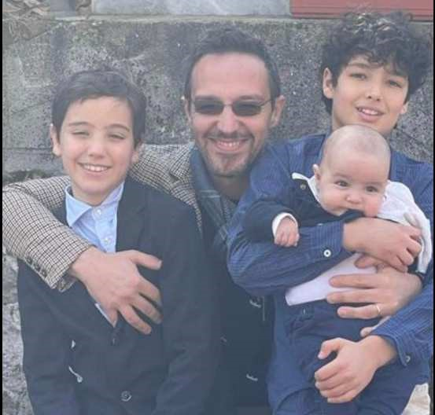
CV in compliance with Italian law 'art. 13 D. Lgs. 196/2003 and art. 13 GDPR (UE 2016/679)
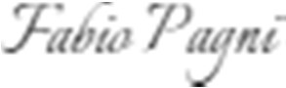
. 10 /1/2025 Milan

The undersigned is aware that, pursuant to art. 76 of Presidential Decree 445/2000, false declarations, false documents and the use of false documents are punished pursuant to the penal code and special laws. Furthermore, the undersigned authorizes the processing of personal data pursuant to art. 13 GDPR 679/16 – “European Regulation on the Protection of Personal Data”.

